Cook Book: virtual kitchen assistant

# 1. Introduction

* **Project Title:** CookBook: Your Virtual Kitchen Assistant
* **Team ID** : 44FC73688BF96E2AC3F4086A6D0B7987
* **Team Leader:** LIKITHA V & vlikitha65@gmail.com
* **Team Members:**
* AKILA MR & akilakeerthy10@gmail.com
* MUNIRA D & muniramunira850@gmail.com
* MONIKA A & monikaanbarasan18@gmail.com

# 2. Project Overview

* **Purpose:** *Your Virtual Kitchen Assistant" details a digital platform for managing recipes, featuring a recipe library, user-added recipes, step-by-step instructions, and potential AI-driven personalized recommendations for ingredients or dietary needs.*
* **Features:**
* *Extensive Recipe Library*
* *Step-by-Step Guidance*
* *Hands Free Operations*
* *Natural Language Processing(NLP)*
* *Personalized Recommandations*
* *Dynamic Feedback*
* *Responsive Design*

# 3. Architecture

* **Frontend:** *the frontend would be a responsive, intuitive web or mobile application built with frameworks like React or React Native, featuring a clean, modern UI for recipe browsing, saving, step-by-step guidance, and user profile management, with potential voice control integration for hands-free operation*
* **Backend***: A "backend for cookbook your virtual kitchen assistant" involves a server-side application, potentially using a serverless RESTful API, that handles user accounts, recipe storage, searching, and other data-driven features to manage a digital cookbook and provide virtual kitchen assistance.*
* **Database:**  *A "Cookbook" virtual kitchen assistant database can use a relational database like PostgreSQL or MySQL to store recipe information, including user accounts, categories, recipes, and ingredients.*

# 4. Setup Instructions

* **Prerequisites:**

*To create a virtual kitchen assistant cookbook, prerequisites include Node.js and npm for backend development, React.js for the frontend UI, and knowledge of web application development, particularly with an API client and integration tools like RapidAPI.*

**Installation Steps:**

* Find the App
* Search for "Cookbook"
* Download the App
* Open the App
* Follow On-Screen Instructions
* Add Recipes

# 5. Folder Structure

A folder structure for a "Cookbook: Your Virtual Kitchen Assistant" could include src/components for UI elements like RecipeCard.js, src/pages for views like HomePage.js and RecipeDetail.js, src/utils for helper functions like api.js and constants.js, src/assets for images and icons, and a root App.js file to manage the application's layout and routes, according to a standard web application architecture.

# 6. Running the Application

* **Frontend:** To run your "Cookbook: Your Virtual Kitchen Assistant" frontend, use the command npm start after navigating into your project's directory and installing dependencies with npm install. This will launch a development server, making your application accessible at http://localhost:3000 in your web browser, assuming the project uses React as indicated by common project structures.

**.Backend:**

environment, install any required dependencies (like Flask or Django packages), and then execute the main application scr

* **Access:**  To access "Cook Book: Your Virtual Kitchen Assistant", you would typically find and click the application's executable file or icon on your device, or navigate to its web URL in a browser, to launch and interact with it as your digital culinary companion.

# 7. API Documentation

* **User:**

For "Cookbook: Your Virtual Kitchen Assistant," user-facing API documentation would likely be integrated into the application itself, guiding users on how to use voice commands, search for recipes, adjust timers, and get AI-powered cooking assistance.

* **Projects:**
* Recipe Search and Retrievals
* User Management
* Cooking Assistance:
* **Chats:**
* There isn't a single "COOKBOOK Your Virtual Kitchen Assistant" API; rather, various APIs and platforms, like OpenAI's Assistants API, can power such an application by handling the core chat, conversation state, and tool integration for tasks like recipe search and ingredient management. To document its API, you would create endpoints for your kitchen assistant's specific features, such as fetching recipes, adding to a grocery list, or tracking user dietary preferences, and define the data structures (e.g., JSON) for requests and responses, as shown in the general OpenAI Cookbook examples.

# 8. Authentication

# 9. User Interface

* Visual Design
* Recipe View:
* Search & Navigation
* Personalization

1. **Screenshots or Demo :**

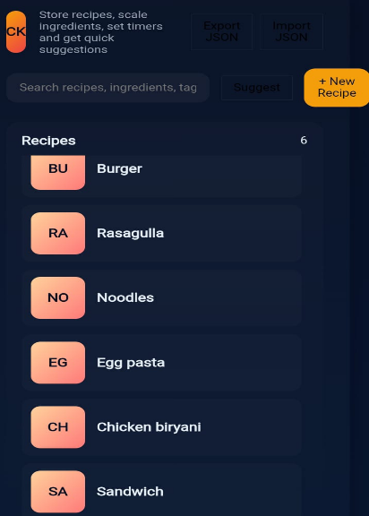

1. **Known Issues :**

Known issues with virtual kitchen assistants like Cookbook include misinterpreting instructions, confusing users about measurements and utensils, and technical difficulties like display times and configuration issues. Users may also have trouble finding recipes and classifying ingredients, as well as potential data privacy and manipulation risks from AI-based systems.

# 13.Future Enhancements :

"Cookbook" include AI-powered personalized meal planning and ingredient recognition, augmented reality (AR) overlays for interactive cooking guidance, voice control for hands-free operation, real-time inventory management to reduce food waste, and smart integrations with smart kitchen appliances for a more automated and efficient culinary experience.

1. Conclusion:

A "Cookbook" acts as your virtual kitchen assistant by providing a user-friendly platform for discovering, organizing, and creating recipes, revolutionizing the culinary experience for both new and experienced cooks.